1.Table: Departments Attributes:
department_id – Primary Key , department_name
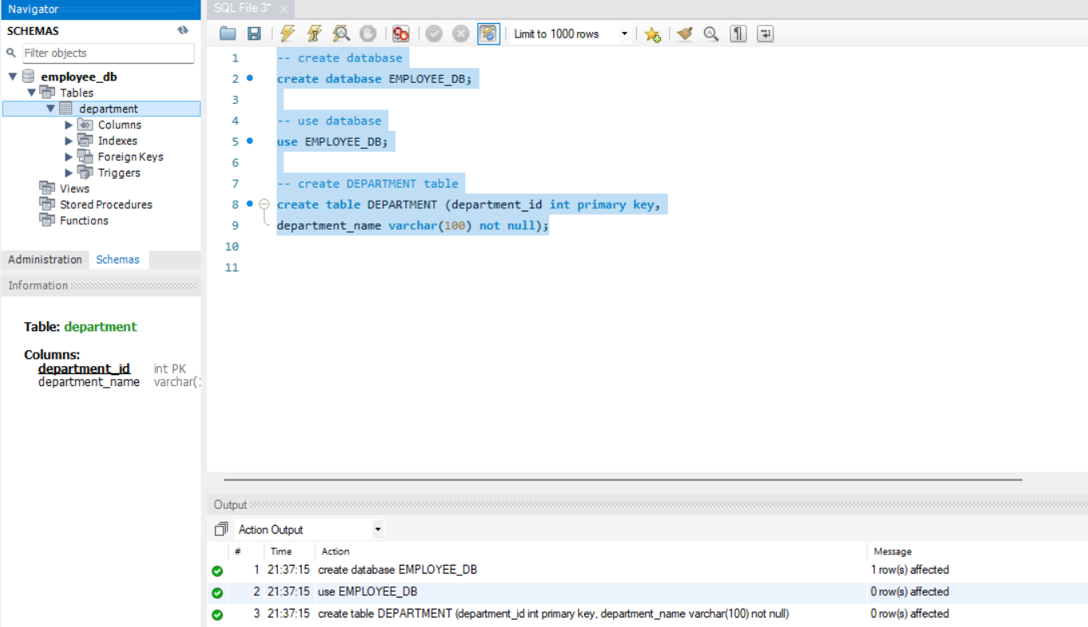
2.Table: Location Attributes:
location_id – Primary Key & location_name
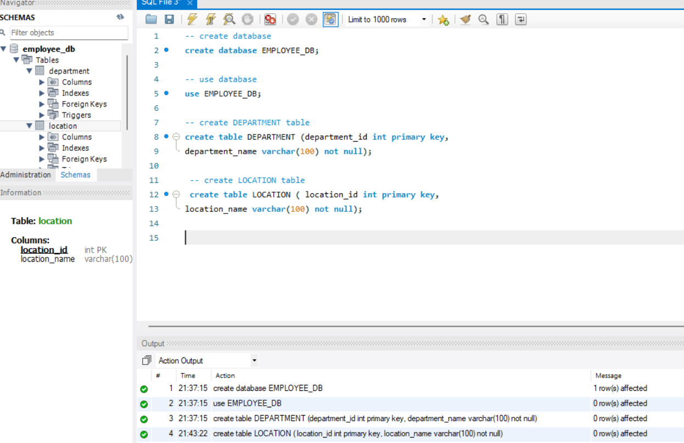
3.Table: Employees Attributes:
- employee_id – Primary Key
- Employee_name
- Gender
- Age
- Hire_date
- Designation
- Salary
- department_id – Foreign Key referencing department(department_id)
- location_id—Foreign Key referencing location(location_id)
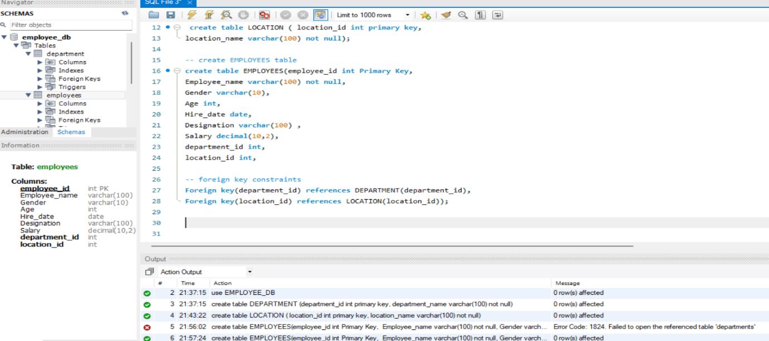
Tasks:
DDL Commands
1. Database and Table Creation (CREATE):
● Create a Database for this project
● Create all three tables in MySQL with appropriate data types and relationships.
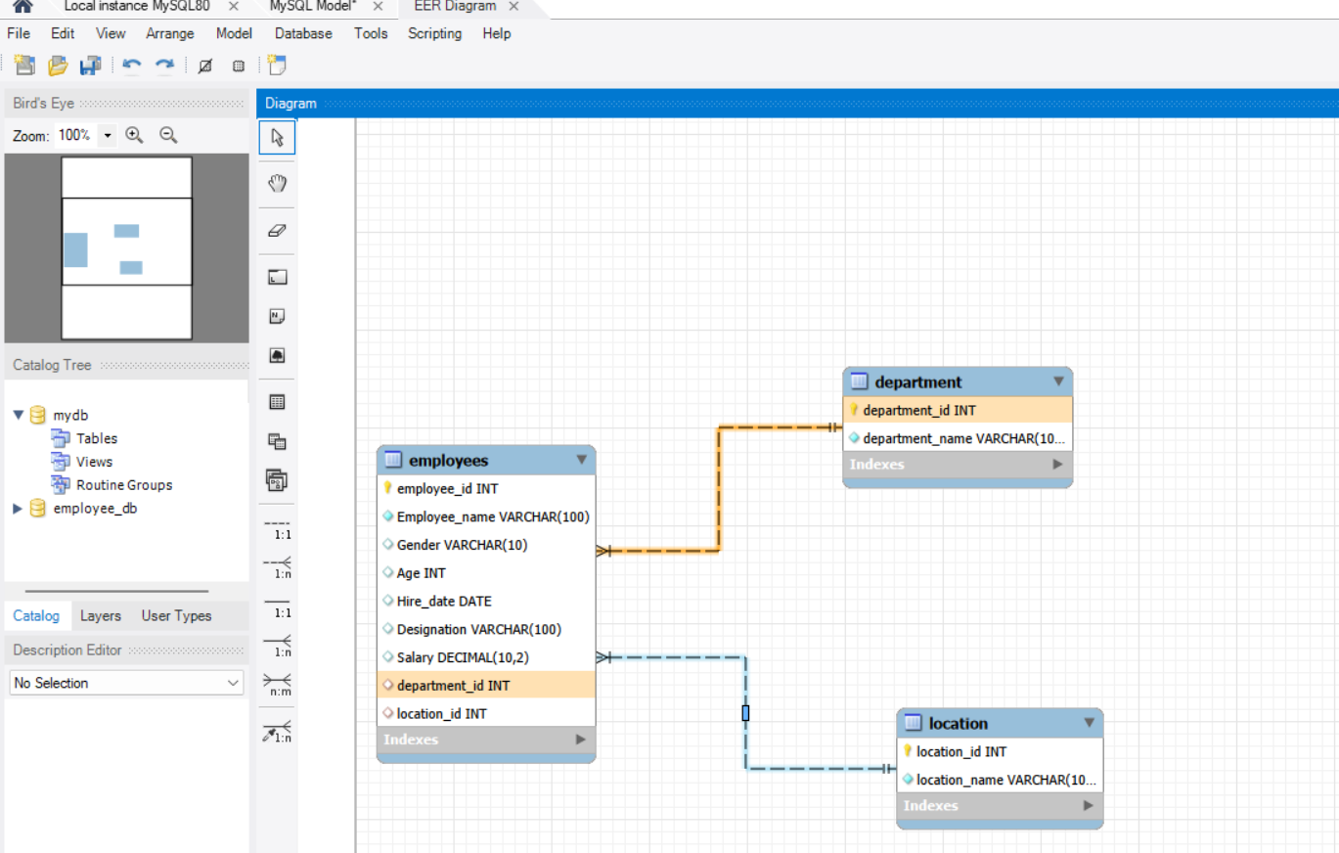
2. Table Alteration (ALTER)
● Add a new column named "email" to the Employees table to store employee email addresses.
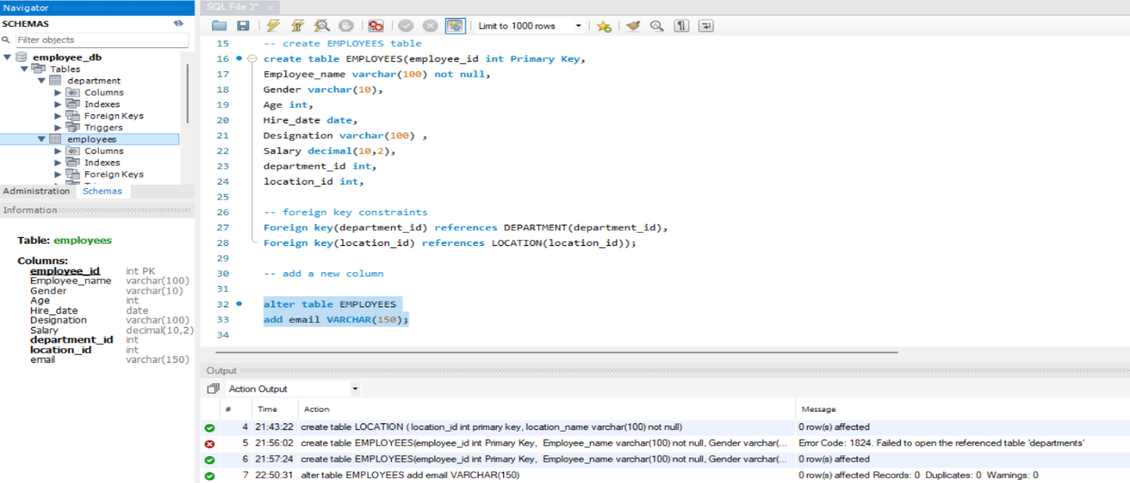
● Modify the data type of the "designation" column in the Employees table to support a wider range of values. 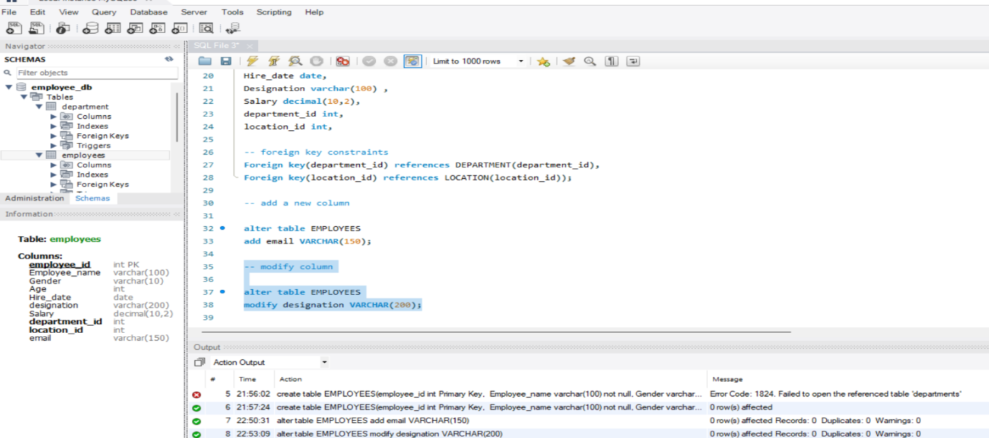
● Drop the “age” column from the Employees table. 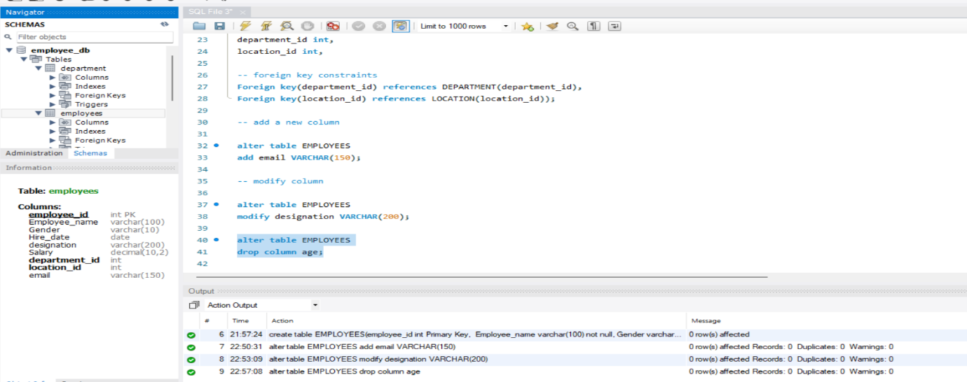
● Rename the “hire_date” column to “date_of_joining”. 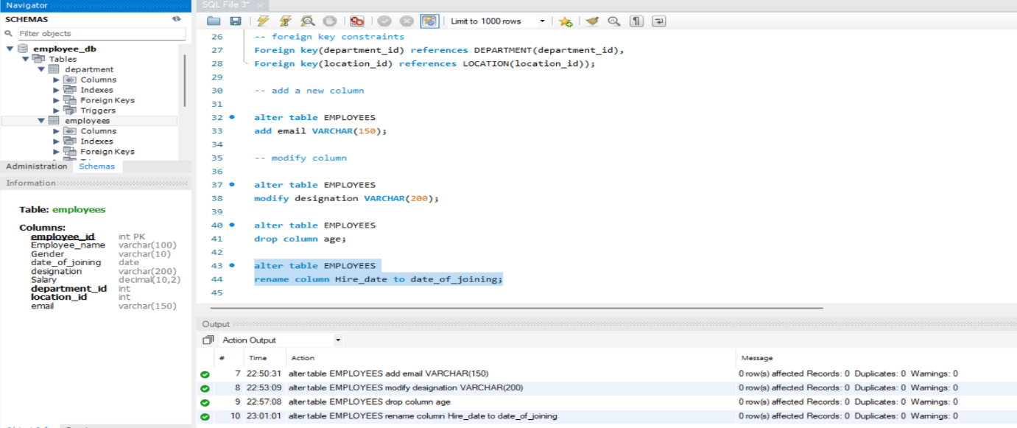
3. Table Renaming (RENAME):
● Rename the "Departments" table to "Departments_Info". 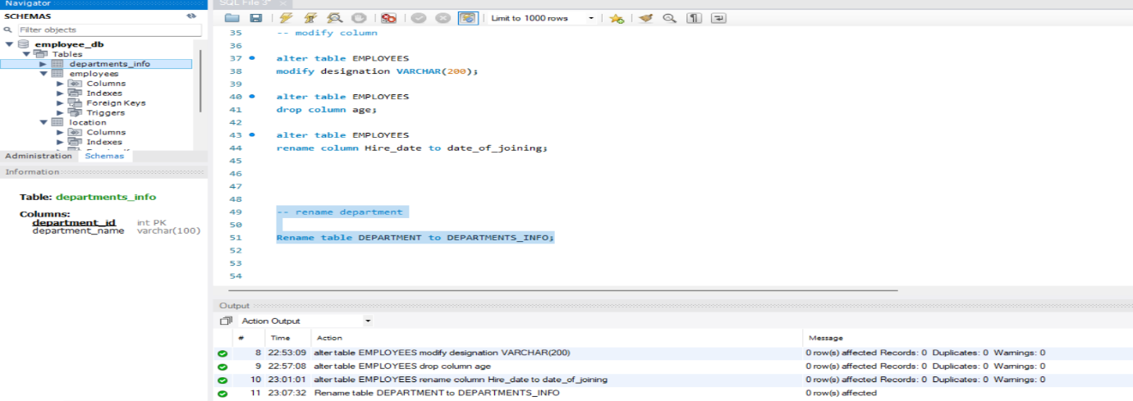
● Rename the "Location" table to "Locations".
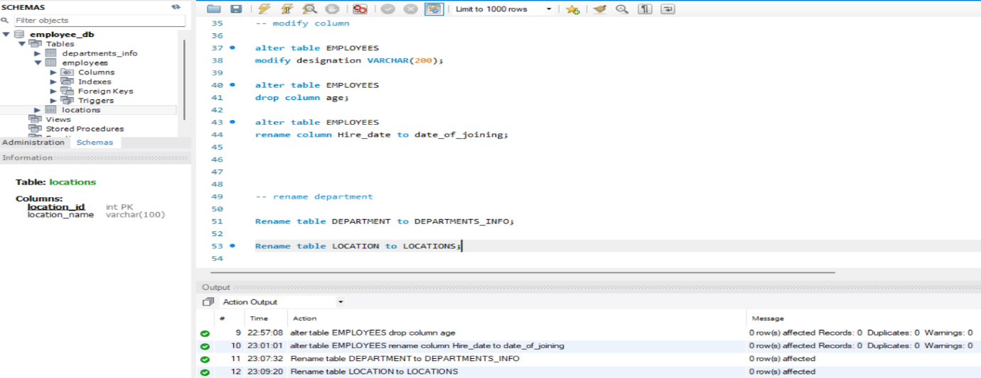
4. Table Truncation (TRUNCATE):
● Truncate the Employees table. 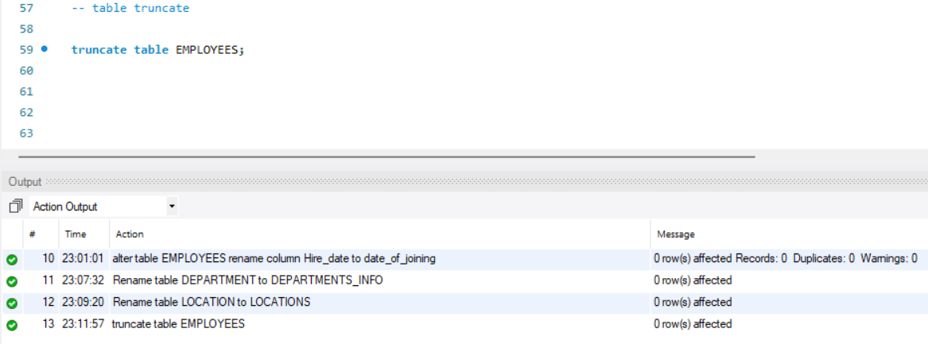
5. Database & Table Dropping (DROP):
● Drop the Employees table and then the “employee” database. 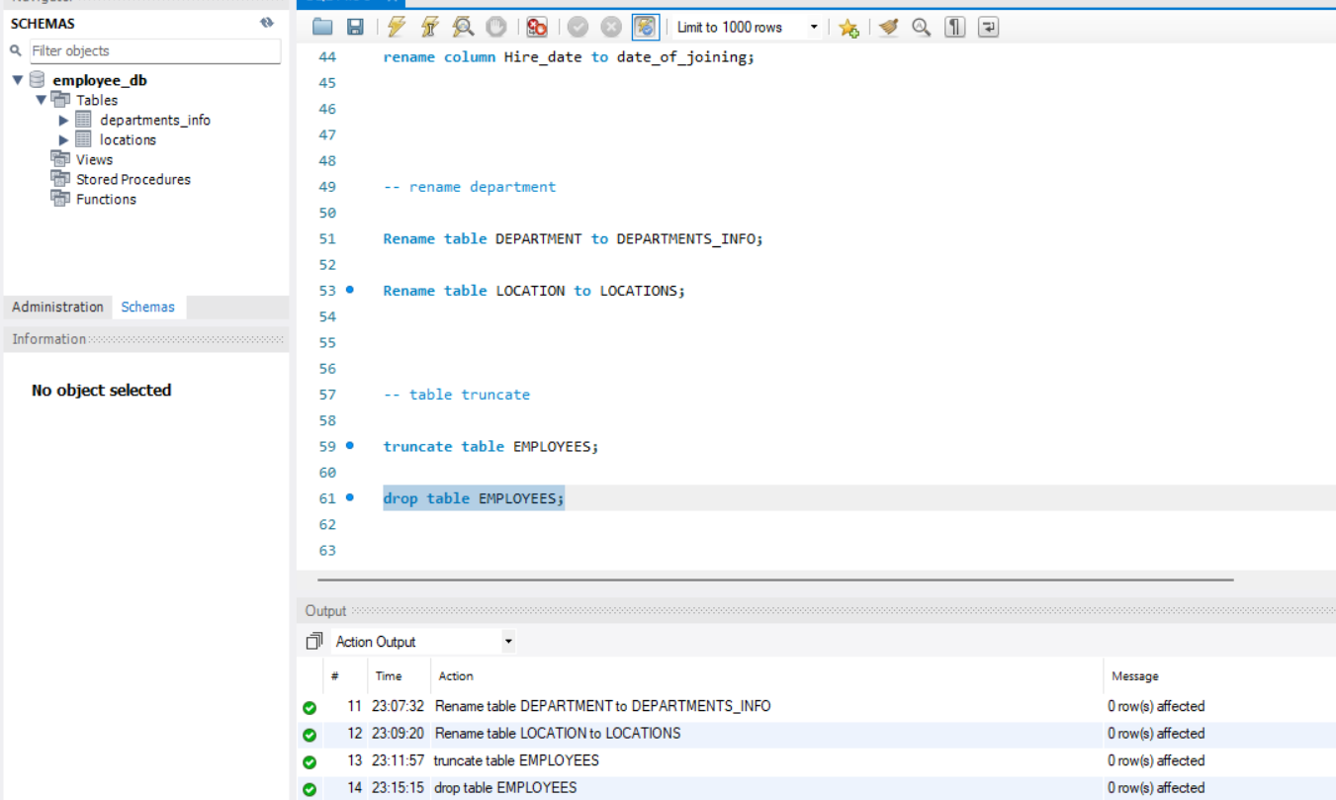
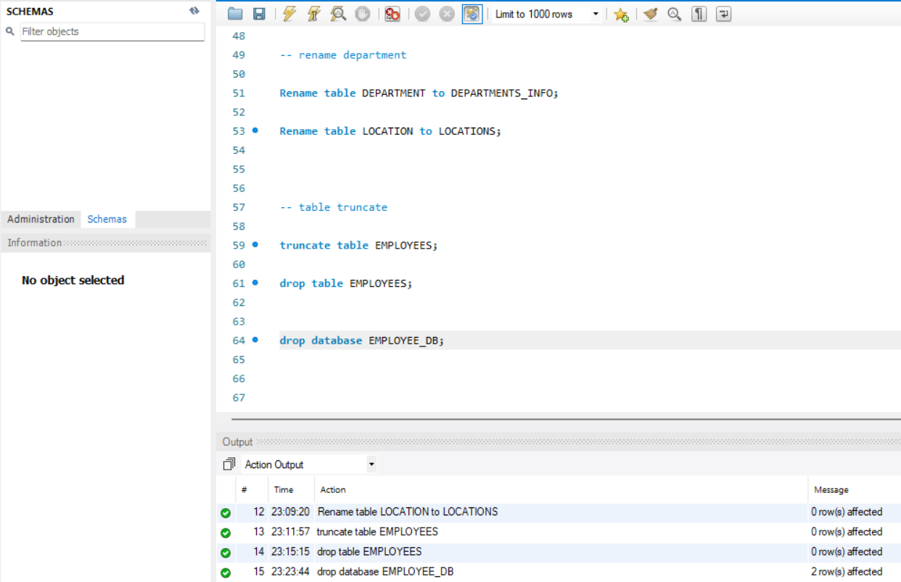
Tasks:
Constraints –
1. Database Recreation:
● Drop the 'employee' database if it exists
● Recreate it using the provided schema, ensuring that all tables are created with the appropriate constraints as instructed.
● Establish links between the "department_id" and "location_id" fields in the "employees" table and their respective tables.
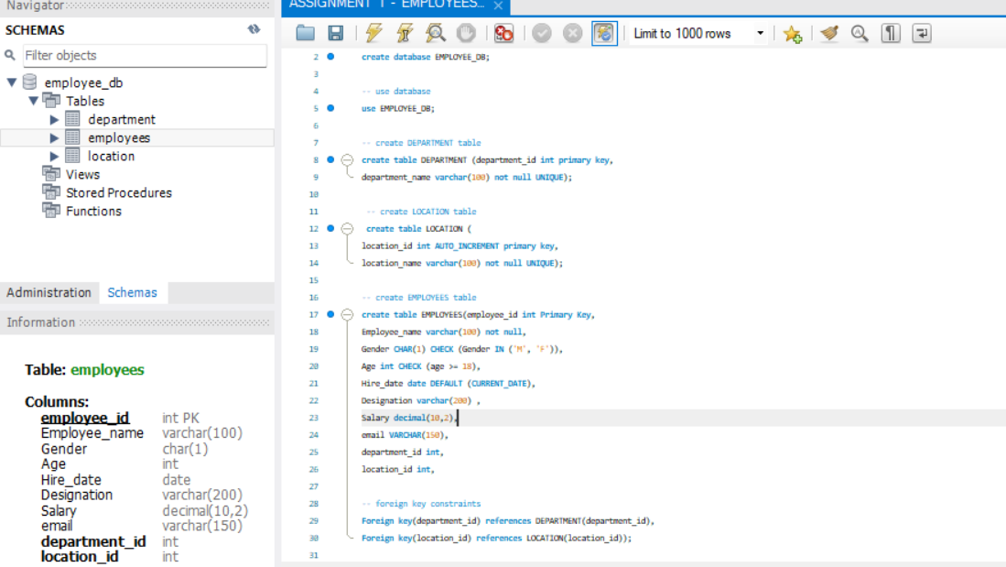
2. Departments Table:
● Ensure that the "department_id" uniquely identifies each department.
● Set up constraints on the "department_name" to avoid duplicate and null entries.
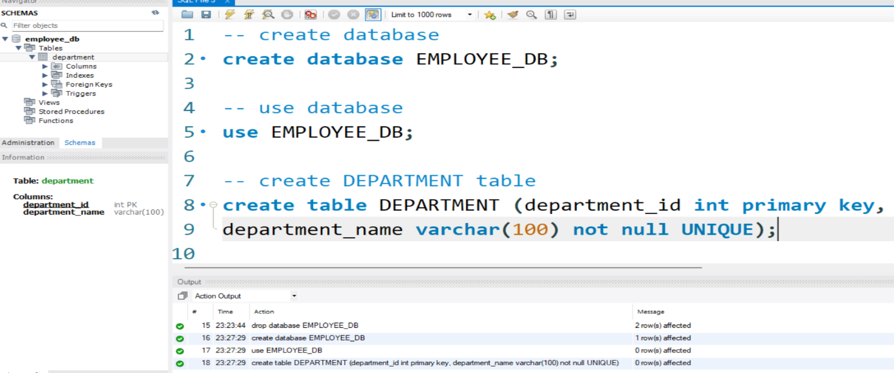
3. Locations Table:
● Establish a mechanism to automatically generate unique identifiers for each location, ensuring that they are incremented sequentially.
● Implement constraints to prevent the insertion of null and duplicate locations.
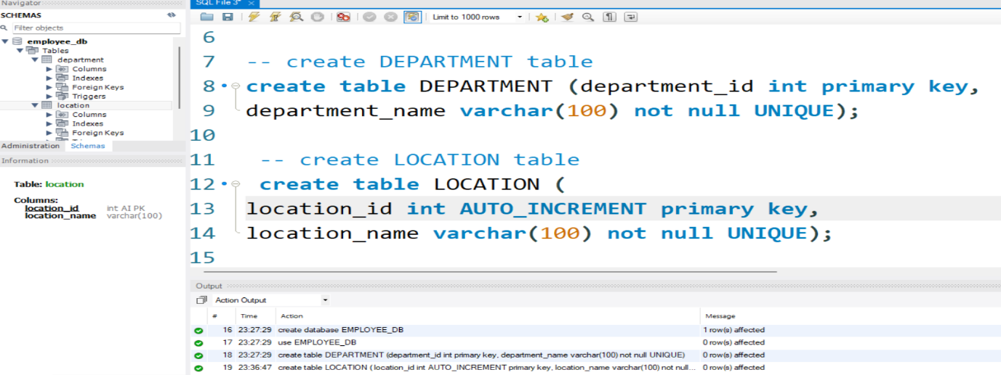
4. Employees Table:
● Guarantee that each employee has a distinct identifier.
● Create a restriction to ensure that the employee's name is always provided.
● Limit the acceptable values for the "gender" field to only 'M' or 'F'.
● Enforce a condition to ensure that the employee's age is 18 or above.
● Automatically assign the current date to the "hire_date" field if not specified.
